Arpeggio Archipelago

Introduction
An arpeggio is a group or sequence of notes played on an instrument. The groups of notes that form the arpeggio are usually part of a musical chord or scale. An archipelago is a group or cluster of islands that were formed tectonically; but that my friend is another story… You have to admit it made for a snappy name.
In this workshop we will discuss some basic arpeggio forms on the hammered dulcimer. We will see how the notes in the arpeggios are related to the scales and chords where the notes came from. We will learn some fun exercises based on arpeggios.

Why Arpeggios?
Lets face it practicing scales is not always that fun. Arpeggio exercises however can be very fun! The exercises presented here are designed to help students learn the “map” of the hammered dulcimer and to help them learn chording patterns. It is important understand the crossover points for your hammering patterns. We cover crossovers in this workshop. An alternating right-left-right pattern (or left-right-left) is suggested for most of these exercises.
The “numbering” notation used in this document requires an explanation. For instance the “2-2” notation is a pattern sequence where two notes are on one side of bridge and two on the other side. This handout is mostly a device to remember the concepts presented in the workshop.
Basic Arpeggio:
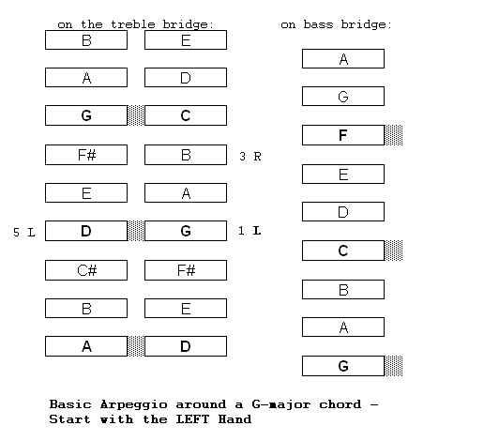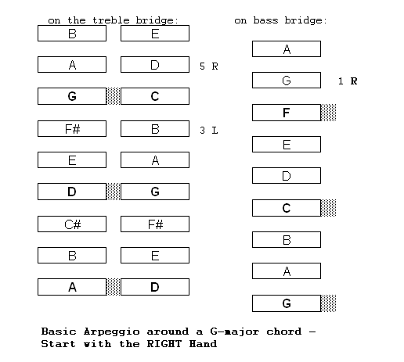
Exercises:
Single Octave arpeggio form (Play in key of G-major or D, C, A…) Start on Marked Note - Start L (treble bridge) 2-2 - Start R (treble ridge) 3-1
- Start L (bass bridge) 2-2 - Start R (bass bridge) 3-1
Double Octave arpeggio form (Play in keyG-major or D, C, A…) Start on Marked Note - Start – L (bass bridge) 2-2 → 3-1 - Start - R (bass bridge) 3-1 → 2-2
I-IV-V Exercise single Low Octave - In key of G: use the chords C to G to D (In key of C use the chords F to C to G)
- Start –L (bass bridge)
- Start - R (bass bridge)
I-IV-V Exercise Double Octave - In key of G: use the chords C to G to D (In key of C use the chords F to C to G)
- Start – L (bass bridge)
- Start – R (bass bridge)
Other Arpeggios: Minor key; 4th instead of third; whatever you can come up with…
Advanced Arpeggio’s
More Advanced Exercises:
Minor key Arpeggios
- Same patterns as major arpeggios but start on note one above a marked note
- You will be playing minor chords instead of major
Compact Double Octave Arpeggio:
- Instead of 2-2 → 3-1 pattern, use 2-2 → 1-3
- Go back and forth between: 2-2 → 1-3 and 2-2 → 3-1
Triple Octave arpeggio (from D-major, that is if you have low D)
- Start - L (base bridge) 2-2 → 3-1 → 4 - Start - R (bass bridge) 3-1 → 2-2 → 4
Compact I-IV-V:
Preliminary: Understand I-IV-V means
- Play chords starting on white notes: G, C, D
- The method requires a total of seven courses
Compact I-IV-V
- The compact version only requires five courses (this requires a demonstration)
- The advantage is you can play all three chords staying in a tighter place
- This can be helpful for jamming

Pachelbel’s Canon in D:
Chord Progression is all arpeggiated chords:
D-A-Bm-F#m-G-D-G-A
http://en.wikipedia.org/wiki/Pachelbel's_Canon

About The Author
Cliff Cole fell in love with the hammered dulcimer at the Philadelphia Folk Festival three decades ago, and he’s been hammering on ever since. He started off as a drummer playing rock, jazz, and blues, and then carried that musical experience and sense of rhythm over to the hammered dulcimer and folk music. Rounding out his musical expression, Cliff studies acoustic guitar, plays the blues harp, and enjoys singing.
Over the years, Cliff produced six recordings with his family folk group DayBreak, including Lost Cave, which was recorded live inside Lost River Caverns in Hellertown, PA and two recordings with his daughter, accomplished vocalist and poet, Emily Rose Cole.

Cliff’s also plays in a musical duo, Tachyonmetry, where the interplay of the classical guitar and hammered dulcimer are breaking new ground. An EP called Sunset Waterfall has been released. http://tachyonmetry.com

cliffcole@enter.net http://www.daybreakfolk.com/

This document can be downloaded from: http://www.daybreakfolk.com/CliffCole.htm

