Opening New Doors

Introduction
The program says: Let's expand your universe and "to go boldly" where others rarely go. Topics will include: Alternating bass, bending notes, striking two notes with one hammer, string dampening techniques with and without a pedal. We'll leave time for participants to share their own special techniques they use.

This workshop is designed to to give you ideas on how to make your playing more fun and interesting. So let’s start with some basic concepts, and expand from there…

Know Where Your Going – Understand The Dulcimer Map
There are multiple ways to map the dulcimer. But the basic layout is based on the circle of fifths. Find all the marked notes on your dulcimer and see how they match up to the diagram below.

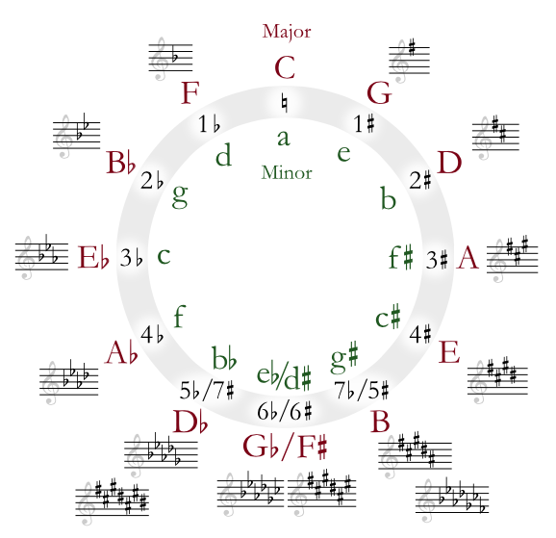
https://upload.wikimedia.org/wikipedia/commons/3/33/Circle_of_fifths_deluxe_4.svg

Learn all the ways the circle of fifths can help you. One, four, five; relative minors; key signatures.
Learn to play more horizontally rather than up and down. Use notes on both the treble course and bass course.

Understand the Common Modes and how they relate to the HD
Ionian Mode - Do-re-me scale. This is called a “natural major” diatonic scale. On the HD start on any marked note and use a “4-4” pattern above. (C to C – on the white notes of the piano)

Aeolian Mode - Another name for a natural minor scale. Uses all the same notes in it’s “relative” major scale.
(A to A white notes on the piano - relative minor of C-Major)

Dorian Mode - “Minor” sounding mode that is similar in form to the Ionian mode but a flatted 3rd and 7th (or minor 3rd and minor 7th) are substituted. The Dorian mode can be played using the same pattern as we use for a major scale, but start on a note one above any marked note. (I will demonstrate) Celtic and other ethnic music often use the Dorian mode. (D to D white notes on piano)

Mixolydian Mode - Similar to the Ionian mode but a flatted 7th is substituted. Start on any marked note and go straight up and down. (G to G white notes on the piano)

Really Learn Your Tunes
Have your sticking patterns down solid, especially in the “hard-to-play” parts of the tune. Learn your tunes on the high-notes, the low-notes and all over the dulcimer. Add embellishments, but in general keep them simple. We don’t want a muddy sound, do we? Learn the chords (or double stops) to the tune. This will help you in a band or jam situation…

Learn Percussion Techniques
By default, if you play the hammered dulcimer, you are a percussionist! Embrace this concept. Learn the basic rudiments: Single stroke, double stroke rolls, flams, and paradiddles. Work on right-hand / left-hand independence. Use both hands “equally”. Work on your left hand (lefties, work on your right hand.)

Alternating Bass Technique
The idea is to (loosely) emulate Travis guitar fingerpicking style on the dulcimer. Alternate your right hand on notes between the bass course and the treble course. Use your left hand to make a melody. This will be demonstrated.

Multiple Ways to Dampening the Strings
A dampener pedal will add a whole new dimension to your playing. I like to use mine the way a drummer plays a hi-hat cymbal… But you don’t need a pedal to get that dampened sound. Use your fingers or masking tape.

Dampening with your Fingers: Gently press the strings on the bridge with one hand. Find the right pressure or let go just when you strike the note with your hammer in the other hand.

Dampening with Masking Tape: Apply tape down the center on top of both bridges. Masking tape (usually) will not leave a residue. With practice you can find the perfect way to do it to get the sound you want.

Bending Notes
On the treble course, strike on the right; push down gently on the left. The lower notes work best, but most of them will bend fairly easily. This will be demonstrated.

Striking In-between for Two notes at Once, and Chords
With practice you can find the “tweeners”. This allows you to play actual chords. This will be demonstrated.

Show Us What You Got…
No matter who you are and how you play, you bring something unique to the dulcimer. Through the years as an instructor and a workshop leader, I have enjoyed the riffs and exercises that students have come up on their own; even students who have been playing for a month or less… There is a lot of power in “not knowing” that you are “not supposed to do that”… Don’t be afraid to explore. One of the wonders of music is its infinite possibilities.

Workshop Leader Contact info:
Contact Cliff at:
Cliff Cole
2440 Schukraft Road
Quakertown, PA 18951
215-453-1722
http://www.daybreakfolk.com/
This document can be downloaded from: http://www.daybreakfolk.com/CliffCole.htm

