Basic Music Theory for the Hammered Dulcimer

Introduction
In this workshop we will explore some basic music theory concepts and apply them to the hammered dulcimer. We will start with the simple diatonic or (do-re-mi) scale and then demonstrate two patterns to play this scale on the HD in the “easy-to-play-in keys.” You will be introduced to the concept of “intervals” and then explore major and relative minor scales. We will then map the dulcimer using the “Greek” modes of music. We will also discuss the circle of fifths and how the hammered dulcimer is mapped using the circle of fifths. Then we will map the dulcimer in terms of major and minor chord patterns.
Diatonic Scales: Using the Four–Four (4-4) and Five–Three (5-3) Patterns
A diatonic scale is the basic seven-note scale in western music and includes the “major” or do-re-mi scale. The term “diatonic” means that the scale has a pattern of whole tones (or steps) and half tones. A major scale is made up of two whole tones, a half tone, three whole tones, and a final half tone:
W-W-h-W-W-W-h
C D e F G A b C- Key of C Major (On a piano keyboard the “e to F” and “b to C” don’t have a black note between them...)
Let’s not get bogged down on the whole steps and half steps. We could spend and hour or more on that concept. If you want to further study this fascinating topic, this is your entry point. Just know that this is the way it is... For further study, learn about “tetra-chords”.
Major diatonic scales are easy to find on the dulcimer. Start on any “marked” note. Use a simple four on one side, four on the other pattern (4 - 4) or a five on the right and three on the left pattern (5 - 3). See the examples below of a single octave and double octave scale. Try it on your dulcimer in the key of G.
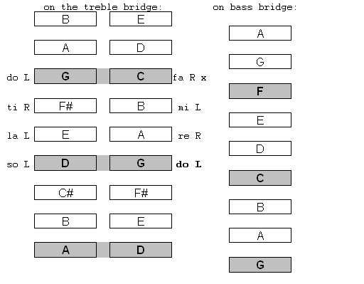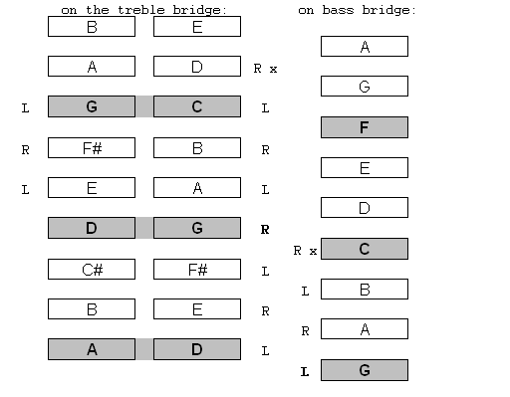
Basic 4 - 4 pattern single octave scale – Start L Two octave scale: 4 – 4 Lower octave; 5 – 3 upper octave
Note crossover point from C to D Note: 5 – 3 crossover point from D to E

Intervals:
“Intervals” simply means the distance between notes. For example, in the Major key of G, the note “A” is the second interval from the note “G”; The note “B” is the third interval; and so on. The eighth interval from G, in this case, is called the “octave”. To form a Major chord we need a “one”, “three” and a “five” to form a “triad” and then we add the “eight” or octave to make the full chord. Play the notes in a G-Major chord on your dulcimer.
We also talk in terms of intervals when describing certain chording patterns such as a I-IV-V pattern often used in rock and blues. So understanding the concept of intervals is important.
Minor Scales (Fun With the Relatives)
Minor scales are also diatonic, using whole and half steps, but lets skip that for now. Just know that what is known as a “natural” minor scale is similar to the Major scale except the third is “flatted”. However before we go down that road, let’s talk about the relatives. No, not your uncles, aunts and cousins, I mean a Major scale and its relative minor. A relative minor scale uses the same notes as its Major Scale, but starts an interval of a 3rd lower. For instance the key of E-minor is the relative minor to the key of G-Major. All that means is that you use only the notes in the key of G-Major to play an E-minor scale.
Try it on your dulcimer. Start on the note-E that is below the note-G on the treble course (We played G-Major in the examples above.) You will play the following notes to make to make the E-minor scale: E-F#-G-A-B-C-x-D-E. (The x-denotes a suggested cross-over point - start the scale with your left hand)
On your dulcimer you can play the E-minor scale by either playing the 8-notes straight up the right side of the treble course, or you can cross-over at the “C-note to D-note” in the scale.
Important: Relative minor scales are easy to find on the dulcimer. Simply find a “marked” note and move two strings below.
Examples: C-Major ➔ A-minor; F-Major ➔ D-minor; D-Major ➔ B-minor
On the piano in the Key-C:
C-Major scale: C-D-E-F-G-A-B-C
Note: There are no sharps or flats (black keys) used in the Key of C (on the piano use only the white notes; C to C)
A-minor scale: A-B-C-D-E-F-G-A
Note: These are all he same notes in the key of C, but starting on A. So “relatively” speaking this is a minor scale. (On the piano use only the white notes; A to A)
Note: In general, songs played in major keys are “happy” or upbeat, whereas songs played in a minor key are generally “sad” or darker... (There certainly are exceptions to this of course...) Now we will explore what it means when a tune sounds “modal”.
Mapping the Dulcimer with the Greek Modes
The “Greek” modes of music are actually medieval terms used to describe different musical scales. Ethnic music that is commonly played on the hammered dulcimer often use or can be described using these modes. Let’s start with the modes that we already “know”.
Ionian Mode - Do-re-me scale that we used above. This is called a natural “major diatonic” scale. On the HD start on any marked note and use a “4-4” pattern above. (C to C white notes on the piano)
Aeolian Mode - Another name for a natural minor scale. (A to A white notes on the piano - relative minor of C-Major)
Dorian Mode - A “minor” sounding mode that is similar in form to the Ionian mode but a flatted 3rd and 7th (or minor 3rd and minor 7th) are substituted. The Dorian mode can be played using the same pattern as we use for a major scale, but start on a note one above any marked note. (I will demonstrate) Celtic and other ethnic music often use the Dorian mode. (D to D white notes on piano)
Mixolydian Mode - Similar to the Ionian mode but a flatted 7th is substituted. Start on any mark note and go straight up and down. (G to G white notes on the piano)
Phrygian Mode - (Not to be confused with the “modern” Phrygian mode.) Using the same (4-4) pattern we used for a major scale start on any note two above any marked note. This will be demonstrated. (E to E white notes on the piano)
The two other modes, Locrian and Lydian, are not as relevant for the hammered dulcimer:
Locrian Mode: Start on any note two above a marked one and go straight up without crossing over. (B to B white notes on the piano)
Lydian Mode: Example - Start on F but only use notes in the key of C. (F to F white notes on the piano)

Mapping the Dulcimer With the Circle of Fifths
The circle of fifths is a very helpful tool for understanding the relationships of the twelve key signatures. The outer circle are the major keys, the inner circle are the relative minors. If you pick any of the keys in the circle, the key to the left is the fourth and the key to the right is the fifth. That helps you find the I-IV-V chords in any key.
It turns out that the hammered dulcimer is mapped to the circle of fifths. Looking at the marked notes on the dulcimer, the major marked keys directly map to the circle of fifths. If you start on a marked G the next marked note up is C, the next marked note after that is F. This corresponds to going counter-clockwise on the circle of fifths (which are fourths - try not to be confused;-)
Once you understand this logic, it shows why the dulcimer is a relatively easy instrument to play in certain keys. It is easy to find the I-IV-V chords in the key of G, D, A and F (to a lesser degree) and on larger instruments the Key of E and perhaps B. But the keys on the “left-side” of the circle of fifths are generally hard to play in without retuning notes.
A nice circle of fifths diagram can be downloaded from Wikipedia: http://en.wikipedia.org/wiki/File:Circle_of_fifths_deluxe_4.svg
Glossary of Terms:
Diatonic Scale: A diatonic scale is any 7-note scale made up of whole and half steps. This includes major and minor scales as well as modal scales. Other scale types include chromatic 12 tone scales (only half steps) or whole tone scales (only whole steps).
Half Steps (semi-tones): The smallest musical interval in western music. the “chromatic” scale is made out of twelve half steps. A whole step is simply two half steps. Example: at a piano start on C and play all the notes in sequence, including the black keys. You will be playing all half steps. We can’t do this on the HD because it is a “diatonic” instrument.
Interval: A term used to describe the distance between notes in a scale or or chord. For instance a major chord will have intervals of one, three, five and eight, where one starting position on the chord. A “C-major” chord is: C-E-G-C 1-3-5-8
Octave: An octave can be defined many ways; In a diatonic scale, it is the “eighth” interval where the scale starts to repeat. If you play all the C notes on the piano, you will be playing octaves.
Key: A way to define the notes or “natural” scale to play a piece of music in. If one says that a tune is in the key of C-major, that means the most or all of the notes in the tune use those notes. A key signature is a way of notating music to define what notes will primarily be played in the piece of music.
Chord: Any set of notes that are played simultaneously. Generally (but not always) musicians try to form chords that are pleasing to the ear, such as major and minor chard. There are thousands of combinations...
Arpeggio: A sequence of individual notes. Arpeggios are often a sequence of notes from a chord. A sequence of the intervals one, three and five in major key would be an arpeggiated “chord”. On the dulcimer this concept works well because of the sustained ringing of the notes.

References:
Every Musicians Handbook: Copyright 1984 Amsco Publications ISBN: 0.8256.2339.1
Wikipedia: http://en.wikipedia.org/wiki/Diatonic
Lorraine Hammond: 2010 SAMW Music Theory Course Material
Hammering Out Music Theory - Janet Harriman http://www.janetharrimanmusic.com/
Many Thanks to: Rob Yoder for proof-reading this document!

About The Author
Cliff Cole fell in love with the hammered dulcimer at the Philadelphia Folk Festival three decades ago, and he’s been hammering on ever since. He started off as a drummer playing rock, jazz, and blues, and then carried that musical experience and sense of rhythm over to the hammered dulcimer and folk music. Rounding out his musical expression, Cliff studies acoustic guitar, plays the blues harp, and enjoys singing.
Over the years, Cliff produced six recordings with his family folk group DayBreak, including Lost Cave, which was recorded live inside Lost River Caverns in Hellertown, PA and two recordings with his daughter, accomplished vocalist and poet, Emily Rose Cole.

Cliff’s also plays in a musical duo, Tachyonmetry, where the interplay of the classical guitar and hammered dulcimer are breaking new ground. An EP called Sunset Waterfall has been released. http://tachyonmetry.com

cliffcole@enter.net http://www.daybreakfolk.com/

This document can be downloaded from: http://www.daybreakfolk.com/CliffCole.htm

