Hammered Dulcimer - Discovery 1: Basics
Cliff Cole: DaybreakFolk.com http://www.daybreakfolk.com/CliffCole.htm

Hammers
There are many types of hammers that one can use to percuss the hammered dulcimer. The type of hammer that you decide to use is a very personal choice. As a trained percussionist, I personally like hammers that have some amount of mass, and are more balanced then the hammers that I see most other people using. Good drum sticks and mallets used for percussion generally have these traits; they are well balanced and have some mass. More mass allows gravity to act on the hammer and assist in the percussion process. This will be explained in the next section, “drop-and-bounce”.

Drop and Bounce
You can visualize the concept of “drop-and-bounce” if you think of a basketball player “dribbling” a ball. The ball bounces on the floor and comes back to the player’s hand. Minimal energy and a simple hand movement is all that is required to keep ball in motion and under complete control. Physicists call this kind of process “simple harmonic motion”.

Percussion using a drumstick or a dulcimer hammer is actually very similar to the basketball example. Gravity will cause the hammer to “drop” onto the string and then “bounce” back up to the starting position. Your fingers, hands, wrist, arms and shoulder are all working together to make this process smooth. When done correctly the player can keep the sticks in constant motion with precise control.

The concept of drop-and-bounce will be demonstrated in the workshop. Both hammers should both start at about six inches above the strings.

Right-Hand Left-Hand Independence
One of the main goals in mastering percussion is to become independent with your right and left hands. The dulcimer is no different than any other percussion instrument; attaining independence between your right and left hands is a big advantage. Some HD instructors like to teach a concept called “left hand lead.” That’s ok, but there is also nothing wrong with “right-hand lead” either.

If you find that when you are playing the hammered dulcimer, that you tend to use one hand dominating over the other, (usually the right hand) you might want to work on bringing your non-dominant hand “up to speed”. The percussion exercises presented in this workshop will help with this.

The Basic Major Scales – Starting on the Marked Notes
In this section new will learn the major scales that start on the marked notes on your dulcimer. We will start with the basic 4 notes on one side, and 4 notes on the other side pattern. Then we will discuss the “duplicate” notes to make the same scale with a “5 and 3” pattern. Please refer to he “Mapping The Dulcimer with Scales and Chords” handout.

Major Scales and Arpeggios
After scales we will learn the basic major chords that use the notes in the major scale. We will use the “Mapping The Dulcimer with Scales and Chords” handout.

Fun Exercises mixing Scales and Chords
In my years of teaching dulcimer, one thing I have learned: Students won’t consistently practice scales. However chord and arpeggio exercises are another matter. We will learn some fun chording exercises that will have you playing all over the dulcimer.

A Short History of The Hammered Dulcimer
The oldest known form of the hammered dulcimer in the Persian Sanṭūr, also spelled Santour or Santoor. This instrument is found throughout the Middle East in places like India, Iran, Turkey, Iraq and Israel. There are many different forms of the instrument such as the Hungarian Cimbalom, the German Hackbrett and the Chinese Yangqin. The most common form in our culture is what we call the hammered dulcimer. The instrument was more common before the piano was invented and had nicknames like “wham-diddle” and “folk piano”. There is a heavy concentration of players in the Michigan area because it was Henry Fords favorite instrument. He financed bands and orchestras with the stipulation that they have hammered dulcimer or Cimbalom players in the group.

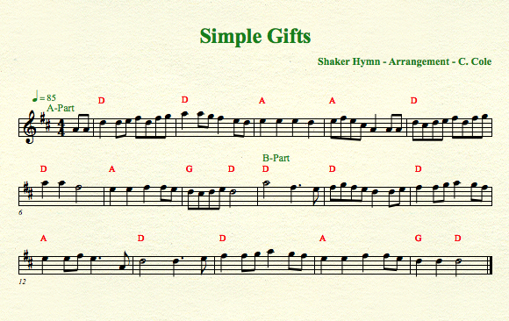

Discovery 2: Mapping the Dulcimer with Scales and Arpeggios
Cliff Cole: DaybreakFolk.com http://www.daybreakfolk.com/CliffCole.htm

Mapping the Dulcimer With Arpeggios
Arpeggios are a sequence of notes, usually a chord.
Please refer to the “Mapping The Dulcimer with Scales and Chords” hand out

Miner Scales and Chords
Once we have master the concept of Major chords, we will do learn similar patterns and exercises using Minor scales and chords.

Fun with the Relatives: The Relationship Between Major and Minor
Once we understand the concept of Major and Minor scales and chords, we will learn how they are related to each other.

An Introduction to some other Modes of Music
Ionian: Major – Bold (Starts on marked notes 4 notes on one side 4 on the other)
Aeolian: Natural Minor – Longing (Starts two below marked same notes as major scale)
Dorian: Close to Minor: Passionate (Starts one above marked note, 4 and 4)
Mixolydian: Similar to Major – Angelic, happy and sad (Starts on marked goes straight up)

The Basic Rudiments and Percussion Sticking Patterns
Always alternate, except when you don’t
In Discovery 1 and 2 we will introduce the basic rudiments such as the single stroke and double stroke roll. Rudiments will be expanded upon in Discovery-3. Some basic patterns are included in this document.

Some Basic Rudiments and Percussion Concepts
- Percussive Arts Society forty essential rudiments
http://www.pas.org/Learn/Rudiments.aspx
- Alternate right and left hand
- Counting the beat out loud – “one and two and three and four and”
- Use a metronome!!!!!!!!!!!!!!!!!!!!!!!!!
- Keep it even
- Playing a basic single stroke roll – R L R L R L R L
- Playing a double stroke roll – R R L L R R L L
- The concept of “doubling”
- Playing a controlled multi-bounce roll
- Paradiddle – “down up tap tap down up tap tap” - R L R R L R L L
  - Hints: Play evenly; the rhythm is in the accents
- Double Paradiddle - R L R L R R L R L R L L
- Flams - LR RL LR RL LR RL LR RL
  - Flam and tap – LR R RL L LR R RL L
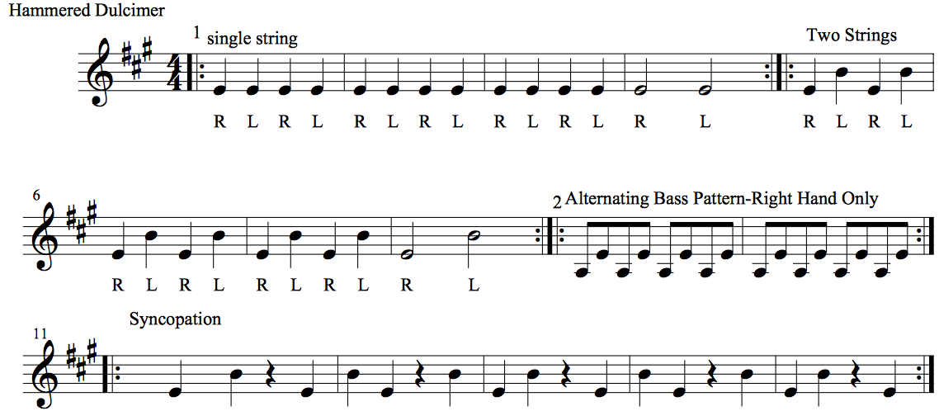

Figure 1 Figure 2: Hammered Dulcimer Percussion Exercises
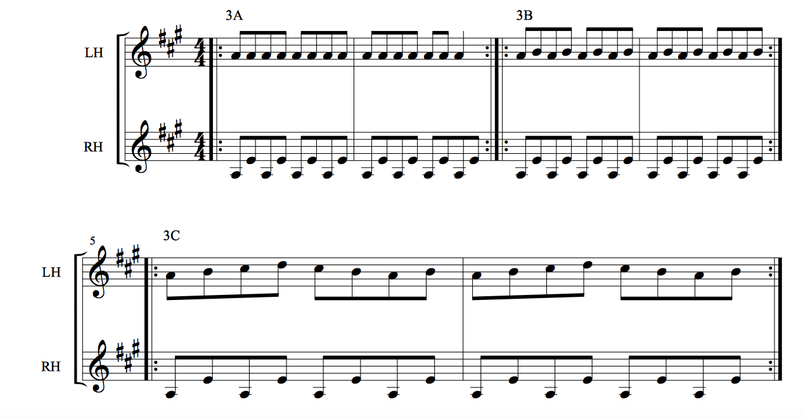
Figure 3: Two Handed Exercises Alternating Base

Discovery 3: Putting it All Together

Review of Discovery-1 and 2
Drop and bounce; Right Hand Left independence; Major and minor Scales; Fun with Arpeggios; The dulcimer map; Basic modes of music; Some basic rudiments; Alternating base and some basic tunes.

Tunes You Already know:
What are some tunes you “already know”? Let’s learn them by ear. If you can sing them you can most likely play them. Some Examples:
Swing Low Sweet Chariot; Take Me Out to the Ballgame, Oh! Suzanna, John B. Sails

